Press Release

Embargoed till Thursday 7 September

Deborah Rogers Foundation Announces Second DRF Writers Award (2018)

- Submissions open from 1 October until 13 December 2017
- Man Booker winner, Anne Enright, to chair the judges
- Ponti, winner of the inaugural award, already sold in 8 countries

The board of the Deborah Rogers Foundation, set up in 2015 in memory of the universally loved and respected literary agent, Deborah Rogers, is delighted to announce that submissions for the second DRF Writers Award will open on l October 2017 and close on 13 December 2017.

The judges of the 2018 DRF Writers Award will be Anne Enright (Chair), Pete Hobbs and Jenny Uglow. They will announce their shortlist in April 2018 and the award will be presented in London on Wednesday 16 May.

'Winning the Deborah Rogers Award was life-changing and provided me with the confidence and support to finish my novel. I feel unbelievably lucky and grateful for it.' Sharlene Teo, the 2016 winner.

THE 2018 DRF WRITERS AWARD

£10,000 will be presented to a first-time writer whose submission demonstrates outstanding literary talent and who needs financial support to complete their work:

- Submissions should take the form of 20-30,000 words of a work in progress, fiction or non-fiction, which is not under option or contract.
- Applicants may not be under contract to any publisher for any work or title.
- Applications are only open to writers who have not previously published a full length book of their own prose writing (including self-published or published on-line) excluding a collection of their own poetry. They may have published short prose writing within a magazine/anthology.
- Entrants must write in the English language and reside within the British Commonwealth and Eire.
- Submissions should be accompanied with a brief synopsis and biographical note.
- Applicants who submitted work for the 2016 Writers Award may re-apply but the work submitted must be new.

www.deborahrogersfoundation.org

NOTES TO EDITORS:

THE 2016 DRF WRITERS AWARD

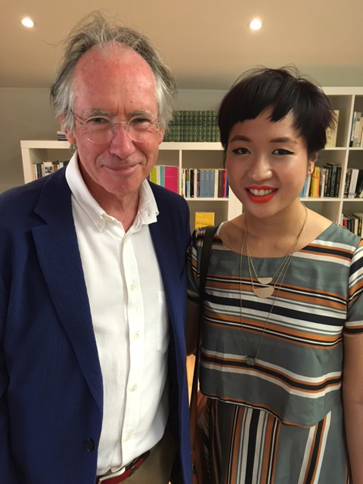

Sharlene Teo was announced as the winner of the inaugural 2016 DRF Writers Award in May 2016 for Ponti, a novel-in-progress. Out of a total of 885 applicants the judges announced a shortlist of three. Ian McEwan, a long-time friend and client of Deborah Rogers, awarded her the £10,000 cheque at a small ceremony in London. The two runners-up each received a book token of £100. The judges were Shena Mackay (Chair), together with Owen Sheers and Kate Summerscale.

Since winning the award, Ponti has been sold to eight publishers around the world and will be published by Picador UK in May 2018 and Simon & Schuster Inc. in the US.

Sharlene comments: 'Winning the Deborah Rogers Award was life-changing and provided me with the confidence and support to finish my novel. I feel unbelievably lucky and grateful for it.'

The two runners-up for the inaugural 2016 DRF Writers Award were:

Imogen Hermes Gowar with her historical novel The Mermaid and Mrs Hancock which has since been sold to Harvill Secker for publication in February 2018.

Guy Stagg for his part travel, part memoir, The Crossway. This was later sold to Picador UK and will be published in May 2018.

DEBORAH ROGERS

A literary agent all her professional life, Deborah Rogers (1938-2014) set up her own agency in 1967, and twenty years later formed Rogers Coleridge & White with Gill Coleridge and Pat White. One of the most influential literary agents of her generation, Deborah was renowned for her taste, her loyalty and her immense generosity in the support she gave to authors. Her sudden death on 30 April 2014 sent a shockwave through the world of publishing and the many writers, publishers and agents whose lives she had touched. At the 2014 London Book Fair, Deborah was presented with the Lifetime Achievement Award in International Publishing, the first agent to have received the honour. She accepted this with characteristic modesty:

“It hardly seems fair to be given an award for what has been a lifetime of such pleasure... those who have entrusted their work to us over the years will never know the intense pride that they have brought, and the anticipation and excitement that greets each new manuscript never palls. I have them to thank most of all.”

THE DEBORAH ROGERS FOUNDATION

Deborah’s particular genius lay in identifying and supporting talented young people. The Deborah Rogers Foundation (DRF) was therefore set up in her memory to continue to seek out and support emerging talent specifically by means of two biennial awards:-

- The Writers Award which gives £10,000 to an unpublished writer to enable them to complete a first book, and The DRF David Miller Bursary which offers work placements in publishing houses worldwide together with £10,000 to help a young agent gain international work experience.

The Foundation is seeking to raise a further £125,000 to complete a total endowment of £250,000 to support these two Awards and secure their future for ten years or more.

The Board chaired by Lord Berkeley of Knighton, Deborah’s widower, comprises people who knew and loved Deborah, including RCW colleagues, writers Ian McEwan and William Fiennes and friends from the publishing world.

Visit www.deborahrogersfoundation.org for further information about the Foundation.

JUDGES OF THE 2018 DRF WRITERS AWARD

Anne Enright was born in Dublin, where she now lives and works. She has published two collections of short stories, published collectively as Yesterday’s Weather; one book of non-fiction, Making Babies; and six novels, including The Forgotten Waltz, which was awarded the Andrew Carnegie Medal for Excellence in Fiction, The Green Road which was shortlisted for the Baileys Women's Prize for Fiction 2016, the 2015 Costa Novel Award, longlisted for the 2015 Man Booker Prize, won the Irish Book Awards Book Club Novel of the Year 2015 as well as the Kerry Group Irish Fiction Award 2016, and The Gathering, which was the Irish Novel of the Year, and won the Irish Fiction Award and the 2007 Man Booker Prize. She is the inaugural Laureate for Irish Fiction.

Peter Hobbs is the author of two novels, The Short Day Dying and In the Orchard, the Swallows, as well as a collection of short stories, I Could Ride All Day in My Cool Blue Train. He is also the co-editor of Sex & Death, an anthology of new short stories. He is a Fellow of the Royal Society of Literature, and a writer-in-residence for the schools literacy charity, First Story.

Jenny Uglow is a former Editorial director of Chatto & Windus, and Chair of the Council of the Royal Society of Literature. Her own books include prize-winning biographies of Elizabeth Gaskell, William Hogarth, Thomas Bewick, and the Victorian architect Sarah Losh, as well as the acclaimed group studies, The Lunar Men: The Friends Who Made the Future, and In These Times: Living in Britain through Napoleon’s Wars, 1793–1815. Her latest book is a biography of Edward Lear. She lives in Canterbury.

BIOGRAPHICAL INFORMATION ABOUT THE WINNER AND RUNNERS-UP OF THE 2016 INAUGURAL DRF WRITERS AWARD

Sharlene Teo
Sharlene Teo (b. 1987) is a Singaporean writer based in the UK. She is the winner of the inaugural Deborah Rogers Writers’ Award for Ponti, her first novel. In 2012 and was awarded the Booker Prize Foundation Scholarship to undertake an MA in Prose Fiction at the University of East Anglia, where she is currently completing a PhD in Creative and Critical Writing. She is the recipient of the 2013 David T.K Wong Creative Writing Fellowship and the 2014 Sozopol Fiction Fellowship.

Publishers already contracted to publish Ponti:
Picador (UK), Simon & Schuster (USA/Canada), Buchet Castel (France), De Bezige Bij (Holland), Aufbau (Germany), Intrinseca (Brazil), Edizioni E/O (Italy) and Hep Kitap (Turkey).

Imogen Hermes Gowar
Imogen Hermes Gowar studied Archaeology, Anthropology and Art History before going on to work in museums. She began to write fiction inspired by the artefacts she worked with, and in 2013 won the Malcolm Bradbury Memorial Scholarship to study for an MA in Creative Writing at UEA.

The Mermaid and Mrs Hancock was a finalist in the MsLexia First Novel Competition and shortlisted for the inaugural Deborah Rogers Foundation Writers Award.

Guy Stagg
Guy Stagg was born in 1988. He read English at Trinity College, Cambridge, where he was a scholar. He later worked in politics and journalism, and has written for The Daily Telegraph, the New Statesman, and the Literary Review. In 2013 he walked from Canterbury to Jerusalem.

The Crossway was shortlisted for the inaugural Deborah Rogers Foundation Writers Award.

For media information, please contact:

Dotti Irving
Four Colman Getty
+44 (0) 20 3697 4240
Dotti.Irving@fourcolmangetty.com

Zoe Waldie or Cara Jones
Rogers, Coleridge & White Ltd
+44 (0) 20 7221 3717
zoew@rcwlitagency.com
cara@rcwlitagency.com

For all further information: www.deborahrogersfoundation.org

August 2017

